Mathematical Practices:
What needs to be in our lessons:
- Fluency: Every ES lesson contains a Fluency component. Some MS lessons contain Fluency activities. Fluencies are not officially included in the Eureka HS curriculum; however, we encourage teachers to pull Fluency activities from earlier grade levels to support student growth.
The fluency practices (sprints, rapid whiteboard exchanges, and other exercises) can be accessed via the Eureka curriculum most easily through Navigator, however, they can also be accessed via embarconline: https://embarc.online/course/view.php?id=44. Embarconline also has links to 3-Act Tasks (application problems),
- Concept Development: Examples and solutions are in the Student and Teacher Editions.

- Problem Sets: The language of Problem Sets varies by grade band. In K-5, Problem Sets are a built in component of every lesson. In 6-12, Problem Sets are not formally part of the lesson; however, teachers should make strategic instructional decisions to use these as they see fit. Both follow a simple to complex progression.There are more problems (at varied levels) available for our students than can reasonably be expected to be done in class and at home. Select these carefully.

- Debriefing sessions: Number talks can be accessed via Embarconline, but following the "closing notes" in Eureka should be sufficient.

- Zearn: Elementary students (Grades 1-4) can access Zearn and are expected to spend 30 minutes per day practicing skills there.

- Exit Tickets can be downloaded and printed from GreatMinds (Eureka) or Embarconline. Exit Tickets can definitely be accessed easily through our Great Minds website. The Basic Curriculum Files, contain all Exit Tickets and Assessment for students. Within the Digital Suite, you can pull these by lesson or under “Student File B” in each Module.
  - In addition, Embarconline offers tons of resources organized by grade and module: For example,
  - 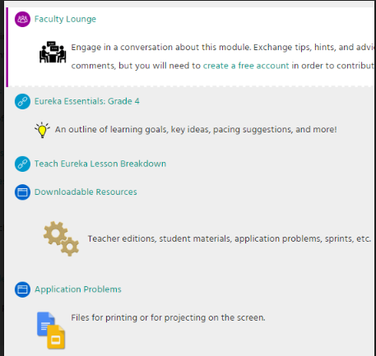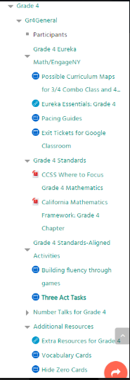

What appears to be a standard practice of downloading worksheets and giving students Level 1* worksheets is incompatible with the fundamental goals of the New Jersey State Learning Standards, Common Core Curriculum and Eureka Mathematics, and therefore is an unacceptable practice. Students need to understand the underlying mathematics BEFORE learning tricks and strategies of simply answering the questions.

*Level 1 refers to Webb's Depth of Knowledge learning levels: Level 1: Recall and Reproduction

"Tasks at this level require recall of facts or rote application of simple procedures. The task does not require any cognitive effort beyond remembering the right response or formula. Copying, computing, defining, and recognizing are typical Level 1 tasks." [ https://www.edutopia.org/blog/webbs-depth-knowledge-increase-rigor-gerald-aungst ]

It is vital that we challenge our students to think deeply about the mathematics -- engage in productive struggle about WHY the mathematics works, rather than perform countless procedures that have little or no meaning. The Eureka mathematics is designed purposely to encourage the students to do this, whereas much of the material available online (through unvetted resources) does not do this, and, instead, shuts off the student's need to understand the mathematics, often by teaching tricks that are not mathematical in nature, but lead to the correct answers.

For example, when we divide fractions, most of us know to keep the first number, change divide to multiply, then flip the second number. This is the extremely abstract algorithm (procedure) that always leads to the correct answer, but how many of our teachers can explain WHY we multiply instead of divide, and WHY we use the first number, but change the second number?

We need to teach the conceptual understanding to the point where the mathematics makes sense to the students, and the answers will follow....not the reverse. Students need to use manipulatives (both physical and virtual). Think of rigorous instruction as a three-legged stool: Conceptual Understanding, Procedural Fluency, and Application must be approached with equal intensity in order to create a rigorous academic experience for students. Remember CPA -- Concrete, Pictorial, Abstract: When students are unable to access material at the abstract level, we move back into the pictorial. When students are unable to access material at the pictorial level, we move back into the concrete. This progression continues throughout all grade levels. Tape diagrams serve as an effective bridge between the pictorial and abstract.

There are very few of these types of rigorous lesson plans available via TPT and a lot of “Level 1” worksheets. I have found that those which are appropriately rigorous are available elsewhere - on sites that have been vetted, such as Embarconline [https://embarc.online/] , CPalms [https://www.cpalms.org/Public/] , and Illustrative Mathematics [https://www.illustrativemathematics.org/] . There are direct links to these sites (and more) on my website: http://mbraverman.weebly.com. I would encourage teachers seeking additional resources to get in touch with me so that we can find appropriate supplements as needed (and I can get a better understanding of what they need, in general).

