Grace A. Dunn Middle School
Family Mathematics and Literacy Night
Tuesday, December 12, 2017

Tonight’s Mathematics Workshops:
The Game of PIG: This game (and its variations) help students practice their arithmetic skills as well as develop an understanding of probability and strategy.

Progressions: Mathematical Progressions help to bring the understanding of mathematics together as a whole. We use addition to assist with multiplication, then move towards a better understanding of mathematics as it applies to Algebra.

Online Access: Mathematics notes (including this handout) from tonight’s presentations will be posted on the school website: http://www.trenton.k12.nj.us/MathematicsResourcePage.aspx (click on the resource page link).

“Fun” Activities To Help Develop Mathematical Skills

Card Games: A deck of cards is an inexpensive gift that opens itself to LOTS of games that involve strategy (which hinges on probability), arithmetic (adding total “points” and scoring), and probability. While many games (such as “War”, “Go Fish” and “Uno”) can be popular and fun, not all games help to develop mathematical skill.

- “War” – The traditional game is sheer luck (no strategy or skill), however, consider the following “rules” changes: Each player plays two cards. The player with the higher product wins all cards in the round. Later (grade 6), you can use two cards and add them, but have red cards valued as negative (for example: 2 of hearts would be negative 2).
- 31: http://www.bicyclecards.com/how-to-play/thirty-one/
- 21 (blackjack): http://www.bicyclecards.com/how-to-play/blackjack/#filter
- Cribbage: http://www.bicyclecards.com/how-to-play/cribbage/#filter (Note: The rules for Cribbage are a little complicated at first, but after learning the scoring, there is a lot of mental arithmetic practice).

Board Games – many of these are available to be played online, however, there are learning advantages to the physical game:
- Monopoly (dice, sums, counting, addition, and subtraction)
- Scrabble (scoring can be tricky)
- Yahtzee (dice, sums, counting, addition)
- Battleship (http://en.battleship-game.org/en/ ) (graphing and coordinates)
- Othello, Chess, Checkers, Backgammon (strategy)
- Go-Moku: Essentially Tic-Tac-Toe, however, use a piece of graph paper, folded into 8ths (16 game boards per piece of paper). The goal is to get 5 in a row before your opponent.
- Mastermind Game: http://www.web-games-online.com/mastermind/
- Connect 4 Game: https://www.mathsisfun.com/games/connect4.html

Puzzles: (https://www.pennydellpuzzles.com/ )
  - Symbolic puzzles:
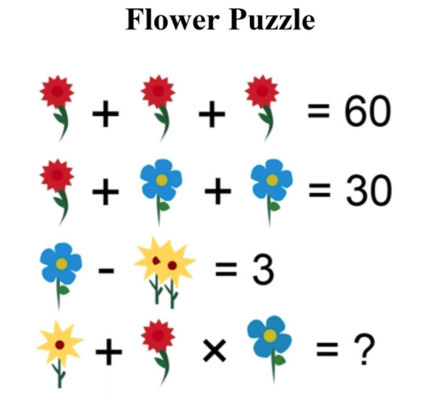

  - Crossword Puzzles: These help to develop “lateral” and divergent thinking skills.
  - Logic Puzzles: These help people to read and think critically
  - Pencil Puzzles: Often, these are math based.

For example: Each letter in the puzzle below represents a single digit so that the arithmetic “works”. Find the solution. [HINT: “G” represents “5”]
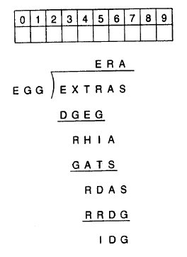
- Ken-Ken: Similar to Soduko, but the goal is to create solutions with sums as well as different characters. http://www.kenkenpuzzle.com/#

More questions? Please contact:
Mr. Michael Braverman, Math Leader: mbraverman@trenton.k12.nj.us or (609) 656.4700 x6138

